How to avoid single bit error, two bit error and odd number of bit error in CRC?

Answer:
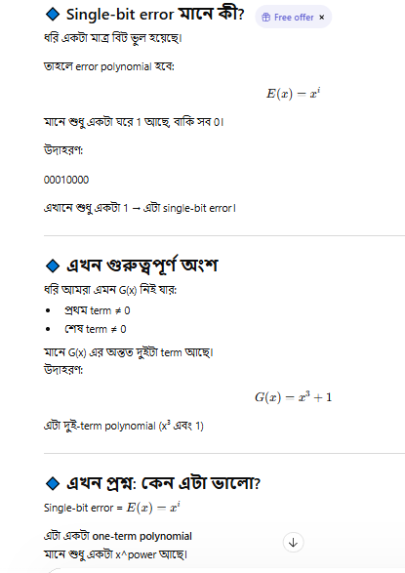

One common type of error is a single-bit error, which can be expressed as E(x) = x i when it affects bit position i. If we select G(x) such that the first and the last term are nonzero, then we already have a two-term polynomial that cannot divide evenly into the one term E(x)

